ICID NEWSLETTER

Dear friends,
Hearty greetings to you all from Indian Centre for Integrated Development (ICID), Nagpur! We hope that all of you are safe and fine! Here we come with some news-bites of the last three months from Nagpur – a heartwarming city of India!

With gratitude to all our friends, we are very happy to inform you that ICID celebrated its 18th birthday with great zeal and vigour on 8th December 2020. Being the pandemic time, only the children of Yuvajyothi, the ICID team and their families and some of the older children of Yuvajyothi took part in the program. The program included a prayer song, Bollywood dances, skit, games and a fellowship meal.

Yuvajyothi has been full of life with 34 children in the past months. Some of the important events that took place in Yuvajyothi were:
The Tribal Maharashtrian art “Warli” painting workshop was conducted by an ICID volunteer where she introduced the concept of this traditional history and culture of folk elements. Children embraced and portrayed this art very enthusiastically on the paper.
Christmas is always so special to every child. It was celebrated with much anticipation and excitement. Children made lovely Christmas trees and lamps and also sold them in the neighboring communities. They made a lovely crib under the creative guidance of Cyprian Creado OP. On Christmas day, they sang carols and offered prayers for all the people affected by the pandemic and for the protection of all ICID friends.

The festivities did not stop the children from regular educational activities including online classes for the younger children (class I to class VIII) and physical classes for the older children (class IX to class XII). Fr. Ephraim Kullu, a guest priest engaged 12 of the children with spoken English classes for two months. Make A Difference (MAD) volunteers have resumed their classes but online for all the children 3 times a week. For this purpose, they have gifted 2 laptops and 4 tablets for the use of the children. Regular life skill education sessions, vocabulary building and newspaper reading activities were organized for the children.

In the last week of December, stone art was made by the children to decorate the garden. Children gave lively feelings to the dead shapes of pebbles and stones, making them real with colours.
In the first week of January, two of the children pursuing class 11, enrolled themselves for police training with an aim to join the police or defence force in the future.

On New Years day, a few students of engineering taught the children a few cognitive skills and mathematic tricks and motivated them by sharing real-time stories for hard work and learning. The children remembered Savitribai Phule, a pioneering educational crusader for women in India on her birth anniversary on 3rd January 2021, by watching a short film on her and by deliberating on the values they need to imbibe.
Children participated in a number of educational sessions conducted by Cyprian Creado and team in the month of January – ‘food wastage and on food banks’, ‘acting and stage presentation’, ‘etiquettes’ ‘the body language and being comfortable in public’.
In the third week of January, nine of the young children participated in a drawing competition named ‘with child’s eye’ conducted by ‘Herd Foundation’ where the paintings of the winners will be displayed on one of the flyovers of Nagpur city.

Adolescent education has gained significant focus of ICID in the past couple of years as the girl children especially from the migrant population are vulnerable to exploitation including school dropout, child labour, early marriage, sexual abuse and early unwanted pregnancies and also ignorance towards reproductive health care. Presently, ICID is working in 24 slum communities with community and family visits, adolescent group formation, life skill education, counseling and other activities. 32 groups with a membership of 320 adolescent girls are functional with regular meetings animated by 3 of the ICID team members.

Savitribai Phule birth anniversary was celebrated on 3rd January 2021 with awareness programs, educational and recreational activities in 8 slum communities with the participation of 575 female children and women with the aim to motivate them for the education and protection of the girl children.

National girl child day was celebrated on 24th January 2021 in 6 slum communities with the participation of 237 female children. Information on gender equality and education of girl children was disseminated through games, thematic dances, skits and speeches.

Nirmaljyothi skill building Centre has been training 25 women in garment making. Three women were referred to boutiques for work after the completion of their training and got employed. Three Self Help Groups have been holding meetings regularly. The members contribute savings every month and have internal lending to the needy members with 2 percent of monthly interest that goes to the group savings.

Deepshikha skill building Centre organized community based play school for 40 children from surrounding slum communities. Through efforts of ICID team, a vaccination (immunization) drive in collaboration with Government department was organized at the centre where 40 children and 12 pregnant women were vaccinated on 13th January 2021.

ICID team reached to over 2000 population in various communities under the CHILDLINE program (24 hours emergency phone and outreach service for children in distress – a project of the Central Government) with child rights protection and childline services information in the past two months. Intervention was done in 38 cases of rescue from child abuse, child labour, child lost, medical sponsorship, educational sponsorship and emotional support and guidance. The CHILDLINE team conducted 6 awareness programs for children in slum communities on sexual abuse, hygiene, COVID -19 through videos and group discussions.

Covid-19 relief services have been provided regularly to the most needy families and individuals by ICID. Medical support was given to 9 individuals and grocery kits (lasting at least for 10 days for a family of 4) were distributed to 205 families. Multi vitamin tablets were distributed to 120 pregnant women.

We express our gratitude for being part of our Dare2Dream/ICID family and for the continued support. We wish you a blessed and spiritually enriching Lenten season. May God bless you and your families.

Herald Dsouza OP
Director
Indian Centre for Integrated Development

A Few Visuals …
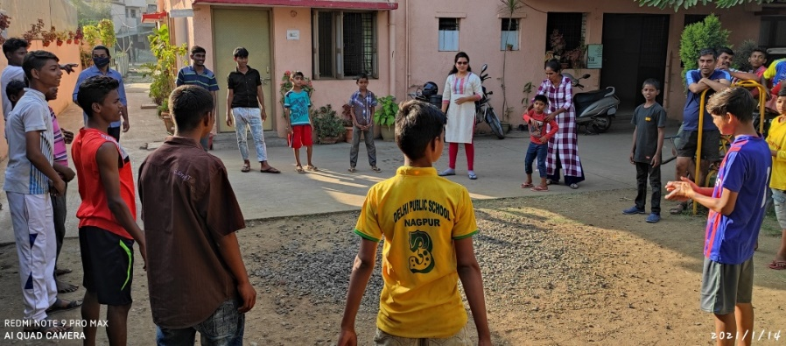

Yuvajyothi - Group Building
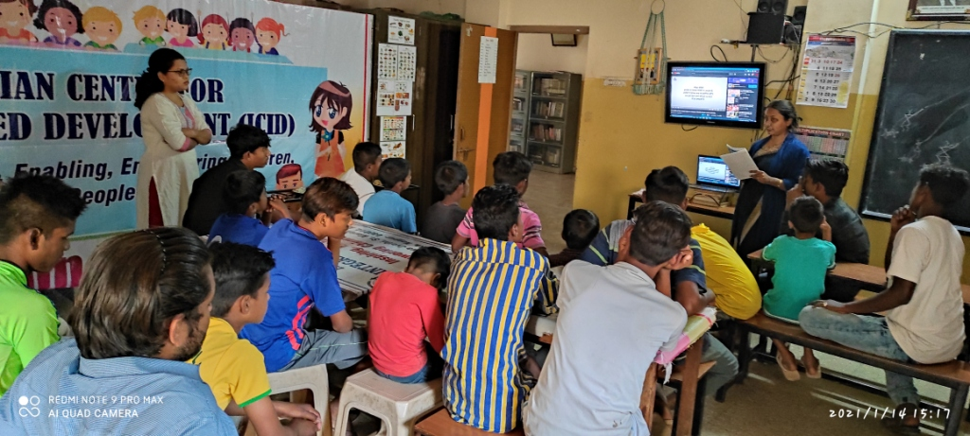

Yuvajyothi - Life Skill Session

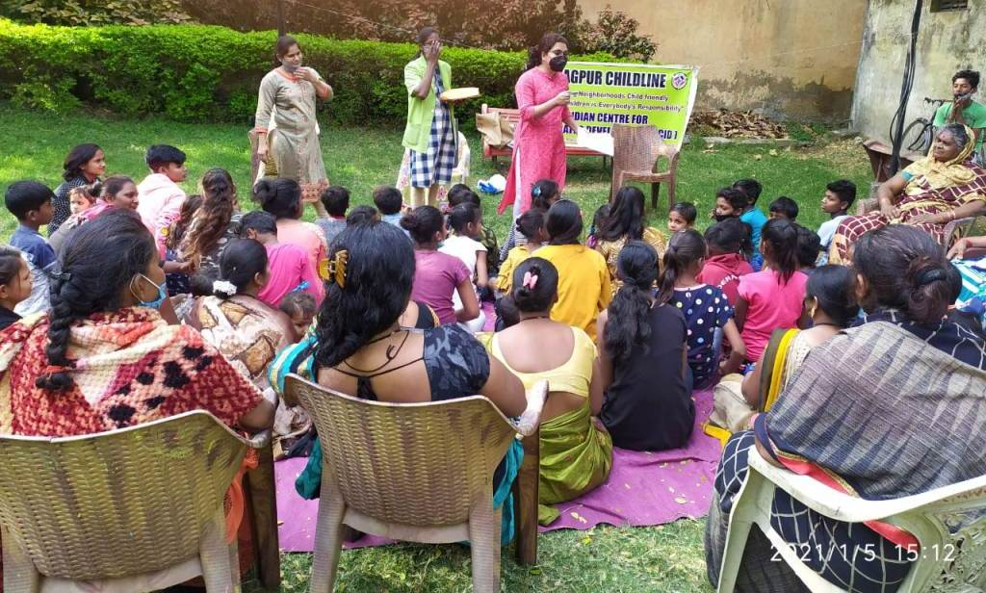

CHILDLINE – COVID-19 Awareness

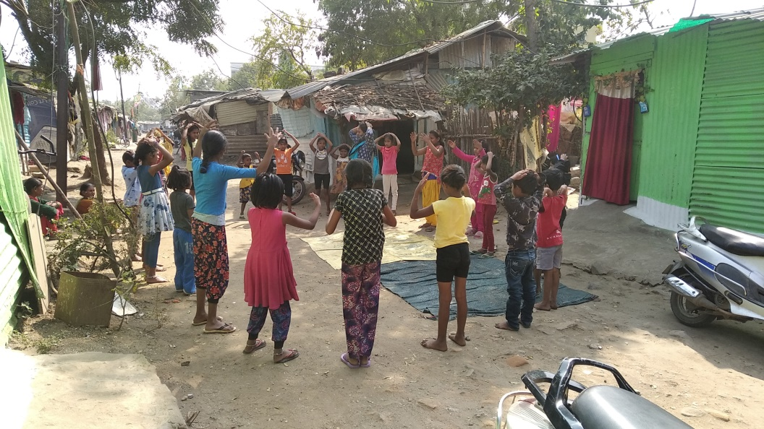

Child Rights – Group Activity

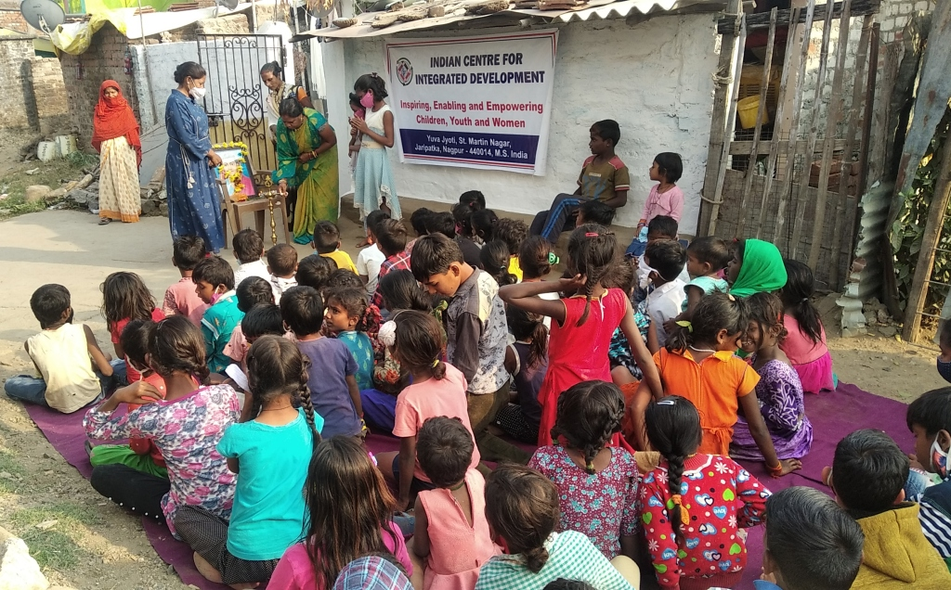

Slum Community Outreach

